Editorial Policies and Guidelines for Anahon Media Platform

Purpose
The purpose of these editorial policies and guidelines is to ensure the integrity, quality, and credibility of content created and published by Anahon Media Platform. These guidelines cover content creation, publication, correction procedures, and safety measures.

Positive / solution journalism policy:
Since AnaHon announced itself as an independent media platform, we also believe in the role of positive journalism.
Based on that, we assure to always be focusing on solutions “solution journalism”
Have multiple approaches and perspectives analysis for any store to assure the full coverage of the story.
In addition to that we keep our audience updated by identifying the buzz topics.
We assure that we apply all what’s mentioned above through multiple types of content “infographics, reels, short documentaries, interviews, posts…” within our chain of channels on different platforms. “WhatsApp, Facebook, Instagram, YouTube, WEBSITE.”
MOREOVER, we ensure to always have the best communications channels with our audience in terms of comments and our live chats also through publishing specific media platforms compatible content.

Responsibilities
- Programs Director
  - Oversees all editorial activities and ensures alignment with the platform's vision and mission.
  - Chairs the weekly editorial meeting.
- Production Manager
  - Manages day-to-day production activities and ensures content quality.
  - Holds daily meetings with Project Officers, reporters, content creators, and podcasters.
- Project Officers (of each program)
  - Each Project Officer is responsible for the content and operations of their specific program.
  - Coordinates daily with reporters, content creators, and podcasters.
  - Participates in both weekly editorial meetings and daily production meetings.
- Reporters
  - Responsible for gathering and reporting news and stories.
  - Attend daily meetings with their respective Project Officers and the Production Manager.
- Content Creators
  - Develop multimedia content such as articles, videos, and social media posts.
  - Attend daily meetings with their respective Project Officers and the Production Manager.
- Podcasters
  - Produce and host podcast episodes.
  - Attend daily meetings with their respective Project Officers and the Production Manager.

Editorial Meetings
- Weekly Editorial Meeting
  - Participants: Programs Director, Production Manager, Project Officers.
  - Purpose: Discuss editorial strategy, upcoming projects, content quality, and any issues or feedback.
  - Agenda:
    - Review of past week's content and performance.
    - Planning for upcoming content and coverage.
    - Addressing any editorial issues or conflicts.
    - Strategic discussions on aligning content with the platform's mission and vision.
- Daily Production Meeting
  - Participants: Production Manager, Project Officers, Reporters, Content Creators, Podcasters.
  - Purpose: Coordinate daily tasks, discuss ongoing projects, and address immediate issues.
  - Agenda:
    - Daily content assignments and deadlines.
    - Progress updates on ongoing projects.
    - Immediate production issues and solutions.
    - Briefing on any urgent news or changes in the editorial plan.

Content Creation

- Accuracy and Objectivity:
  - All content must be thoroughly researched and fact-checked.
  - Content should present information in a balanced and unbiased manner.
  - Sources must be credible, and their authenticity verified.
- Relevance and Impact:
  - Content should focus on topics that are culturally, socially, economically, and politically relevant.
  - Emphasis should be on youth-led initiatives and social issues, empowering the community, especially the youth.
- Ethical Standards:
  - Content creators must adhere to the highest ethical standards, avoiding plagiarism and respecting copyright laws.
  - Any potential conflicts of interest must be disclosed.
- Inclusivity:
  - Ensure representation of diverse voices and perspectives.
  - Content should promote social equity and avoid discriminatory language or implications.

Ethical Handling of Live Content
AnaHon Media Platform recognizes the unique challenges of live content and is committed to ensuring it meets the same ethical and editorial standards as pre-produced content. The following rules apply to all live broadcasts or streaming:
- Pre-Broadcast Review:
Live sessions must be planned in advance and reviewed by the editorial team to ensure content aligns with AnaHon’s values and guidelines.
- Safety and Sensitivity:
Avoid broadcasting content that may compromise the safety, dignity, or privacy of individuals—especially minors, victims, or vulnerable groups—in real time.
- Content Moderation:
A designated moderator must be present during live sessions to monitor real-time comments, remove harmful content, and respond to inappropriate interactions if needed.
- Emergency Protocols:
In the case of unexpected or harmful content during a live session, moderators and hosts must be empowered to end or pause the broadcast immediately.
- Transparency:
Clearly indicate when content is being streamed live, and ensure viewers understand the nature of the session and whether it may include sensitive material.

Ethical Handling of Violent and Explicit Content
AnaHon Media Platform is committed to the ethical and responsible portrayal of violent, graphic, or distressing content. The following standards must be upheld:
- Editorial Justification:
Violent or explicit content must only be used when it is essential to understanding the story and serves a clear public interest.
- Sensitivity and Respect:
Graphic content should be presented with respect for victims, survivors, and affected communities. Sensationalism must be strictly avoided.
- Content Warnings:
If publishing content that could be disturbing to viewers (e.g., blood, violence, distress), a clear content warning must be included beforehand.
- Minimization of Harm:
Whenever possible, use blurred visuals, cropped framing, or descriptive alternatives to avoid unnecessary exposure to graphic imagery.
- Editorial Oversight:
All decisions regarding the inclusion of violent or explicit content must be reviewed and approved by the Programs Director or Production Manager.
This policy ensures that AnaHon remains committed to high journalistic standards while respecting the dignity and emotional safety of its audience.

Use of Artificial Intelligence (AI) in Content Production
AnaHon Media Platform embraces the responsible use of Artificial Intelligence (AI) to enhance the quality and accessibility of its content, while maintaining transparency and editorial integrity. The use of AI at AnaHon includes the following applications:
- Visual Enhancement:
AnaHon uses AI-generated images in some of its short documentaries to enrich the visual experience of viewers. In such cases, a clear note is included to indicate that the images or visuals were generated using AI.
- Fact-Checking Support:
AI tools may be used to support the verification and cross-referencing of facts during the research and editorial process. However, final verification and editorial responsibility remain with human editors and researchers.
- Post-Production and Operations:
AI is also utilized in post-production tasks such as editing, subtitling, translation, and design to improve efficiency and accessibility, particularly for multilingual audiences.
AnaHon is committed to maintaining transparency regarding the use of AI and ensures that all AI-generated content is clearly labeled when presented to the public.

Ethical Treatment of Children and Vulnerable People
AnaHon Media Platform is committed to protecting the dignity, safety, and rights of children and other vulnerable individuals featured in its content. The following standards apply:
- Informed Consent:
When featuring children or vulnerable persons, informed consent must be obtained from a parent, legal guardian, or authorized representative whenever possible.
- Privacy and Anonymity:
Avoid disclosing names, faces, or identifying details unless it is essential to the story and does not pose a risk to the individual’s safety or well-being.
- Non-Exploitation:
Content must not portray children or vulnerable individuals in a sensational, stigmatizing, or disrespectful manner.
- Context and Sensitivity:
Stories involving vulnerable groups should be approached with empathy, accuracy, and care, ensuring they are portrayed as individuals, not as subjects of pity or drama.
- Editorial Oversight:
All content involving children or vulnerable individuals must be reviewed by the editorial team to ensure compliance with these standards.

Publication
- Editorial Review:
  - All content must go through an editorial review process to ensure quality and adherence to the platform’s guidelines.
  - The editorial team must verify the accuracy, clarity, and relevance of the content before publication.
- Approval Process:
  - Content should be approved by the Production Manager and Programs Director before being published.
  - Significant stories or those with potential legal implications should be reviewed by the legal team.
- Transparency:
  - Maintain honesty and integrity in all aspects of content creation and publication.
  - Ensure the safety and confidentiality of sources, especially in situations where disclosure could pose a risk.
  - Be transparent about any affiliations, sponsorships, or potential biases, unless such disclosure would compromise the safety of sources or the intended impact of the message.
  - Maintain honesty and integrity in all aspects of content creation and publication.
  - Ensure the safety and confidentiality of sources, especially in situations where disclosure could pose a risk.
  - Be transparent about any affiliations, sponsorships, or potential biases, unless such disclosure would compromise the safety of sources or the intended impact of the message.
- Reporting:
  - In news reporting, AnaHon Media Platform strives to ensure that it is clear to the audience where a report is being written from when location context is relevant to the story.
  - When location reporting is facilitated or constrained—for example, through an embed with an official army, independent travel with local groups, or access provided by a commercial, NGO, or governmental organization—this should be transparently disclosed, as long as it does not compromise the safety of the journalist, source, or the integrity of the report.
  - The nature of such facilitation (e.g. transportation, permits, or access) should be clearly noted where relevant. Regardless of external involvement, AnaHon maintains full editorial independence and adheres to its ethical standards in all reporting.

Anonymity and Protection of Sources
AnaHon Media Platform is committed to protecting the identity and safety of its sources, particularly those sharing sensitive, high-risk, or whistleblower information. The following procedures guide the granting and handling of anonymity:

When Anonymity is Granted
- Anonymity may be granted when revealing a source’s identity could expose them to harm, retaliation, legal risk, or undue pressure.
- This applies especially to sources in conflict zones, under oppressive regimes, or speaking on sensitive issues (e.g. corruption, abuse, human rights violations).

Approval and Oversight
- The decision to grant anonymity must be approved by the Programs Director or Production Manager.
- Requests are reviewed based on the sensitivity of the subject matter, risk level, and editorial need.

Internal Handling
- The identity of the source must be documented and accessible only to authorized editorial leadership.
- Any communication or documentation must be securely stored and handled in accordance with AnaHon’s safety and digital security practices.

Limitations and Exceptions
- Anonymity may be waived only with explicit written consent from the source, or when required by law following proper legal procedures.
- AnaHon reserves the right to decline the use of anonymous sources if the information cannot be reasonably verified.

Transparency with the Audience
- When anonymity is granted, AnaHon will indicate this clearly to the audience (e.g. “name withheld for safety reasons”) without compromising the individual’s identity.

Moderation of Comment Material and Protection Against Defamation
AnaHon Media Platform is committed to fostering a respectful and legally compliant environment across all its platforms. To ensure this, the following standards apply to public comments and interactive content:
- Defamation and Harmful Content:
Comments that include defamatory statements, hate speech, incitement to violence, or unverified harmful claims are strictly prohibited and subject to removal.
- Moderation and Oversight:
All public comment sections are actively monitored by the AnaHon team. Inappropriate content may be removed, and repeat offenders may be restricted from engagement.
- Respectful Discourse:
Users are encouraged to engage in constructive dialogue. Disagreements must be expressed respectfully, without personal attacks or false accusations.
- Accountability:
AnaHon reserves the right to take action to protect individuals and uphold the integrity of the platform, including reporting serious violations to appropriate authorities.

Correction Procedures
AnaHon Media Platform is committed to maintaining the highest standards of accuracy and transparency. To uphold this, the following correction procedures are applied across all content:

1. Error Handling
- All errors, whether factual, contextual, or editorial, must be addressed promptly once identified.
- Corrections must be made in a way that maintains transparency, clearly indicating:
  - The nature of the error,
  - The correction made, and
  - The date of the correction.
- When possible, the original content (e.g., URL or post) should be updated rather than deleted, with a note on the correction included.

2. Correction Requests
- A clear process is available on AnaHon’s website and communication channels for the public and those involved in a story to request corrections or report inaccuracies.
- All correction requests are acknowledged and reviewed by the editorial team within 48 hours of receipt.

3. Assessment and Approval
- The editorial team assesses the claim to determine:
  - If a correction is warranted,
  - The appropriate form of correction (clarification, update, full correction, or retraction).
- All corrections must be approved by the Production Manager or Programs Director.

4. Documentation
- A corrections log is maintained internally, documenting:
  - The original error,
  - The date it was reported and corrected,
  - The correction made,
  - The platform and content format (e.g., post, reel, article).

5. Visibility and Transparency
- Corrections should be clearly visible and, where applicable, made in the same format and location as the original error (e.g., same post, caption, or time slot).
- In video content, corrections may be made through onscreen notes, descriptions, or updated captions.

Safety Measures
- Journalist Safety:
  - Ensure the safety and well-being of journalists, especially those covering sensitive or dangerous topics.
  - Provide training on safety protocols and risk management.
- Digital Security:
  - Protect the digital security of content creators and sources.
  - Implement strong cybersecurity measures to protect data and communication.
- Anonymous Reporting:
  - Allow journalists and sources to report sensitive information anonymously when necessary.
  - Ensure the protection of whistleblowers and confidential sources.

Support for Staff Exposed to Sensitive or Traumatic Content
AnaHon Media Platform recognizes that some editorial work may involve exposure to disturbing, violent, or emotionally distressing material. The platform is committed to supporting the mental, emotional, and legal well-being of its editorial staff and freelancers.

1. Emotional and Psychological Support
- Team members who are exposed to upsetting content—such as graphic violence, trauma stories, or conflict-related material—can request:
  - Temporary reassignment to less distressing tasks,
  - Time off to recover if needed,
  - Referrals to mental health professionals or organizations specializing in journalist well-being.

2. Internal Reporting and Support
- Staff members may confidentially report emotional or psychological distress to the Programs Director or Production Manager.
- AnaHon will treat these matters with seriousness, confidentiality, and without stigma.

3. Legal Support
- In cases where journalists face legal threats, harassment, or intimidation resulting from their work:
  - AnaHon will provide access to legal advice and support through its legal consultant or trusted legal partners.
  - Journalists will be supported throughout any legal proceedings related to their professional duties.

4. Preventive Measures and Training
- Editorial staff are offered periodic training on managing exposure to sensitive content, identifying signs of distress, and practicing self-care.
- Safety briefings are conducted before assignments with potentially traumatic exposure.

Implementation and Training
- Training Programs:
  - Regular training sessions for staff on ethical journalism, fact-checking, and the platform’s editorial policies.
  - Special training on digital security and safety measures for journalists.
- Monitoring and Evaluation:
  - Continuously monitor the implementation of these guidelines.
  - Regularly evaluate and update the policies to address emerging challenges and maintain high standards.

Handling User-Generated Content (UGC) and Eyewitness News Content

Purpose:
The inclusion of UGC and eyewitness reports in our reporting enhances the authenticity and immediacy of our news coverage. It allows us to cover a broader range of stories, particularly those occurring in real-time or in locations not immediately accessible to our reporters. However, it is essential to handle such content with care to maintain the accuracy and integrity of our reporting.

General Guidelines:

Verification:

All UGC and eyewitness content must be verified before publication. The verification process will assess the authenticity, relevance, and context of the content.

Editorial Review:

UGC and eyewitness content must undergo editorial review to ensure it aligns with our journalistic standards and ethical guidelines. This review will also evaluate the content for potential biases, privacy issues, and ethical concerns.

Transparency:

Be transparent about the source of the content. Clearly label UGC and eyewitness content to distinguish it from content produced by professional journalists.

Disclose the extent of editorial control and verification that the content has undergone.

Ethical Considerations:

Respect the rights and privacy of individuals who provide UGC, ensuring that their safety is not compromised by their contribution.

Obtain proper consent for the use of such content, especially when it involves sensitive or potentially harmful material.

Rights and Permissions:

Secure the necessary rights to use, modify, and distribute UGC. Ensure contributors are aware of our rights usage policy upon submission.

Implementation:

Assign responsibility to a designated editor or team to manage UGC and eyewitness content.

Provide training for staff on the specific challenges and techniques related to handling UGC, including legal implications, verification techniques, and ethical considerations.

Distinction between News, Commercial, and Opinion Content

1. News Content:

Definition: News content includes factual reporting on current events, issues, and stories of public interest. This content is based on verified information and aims to provide an unbiased and comprehensive understanding of the subject matter.

Guidelines:

All news content must be thoroughly researched and fact-checked.

Ensure the use of credible sources and provide balanced coverage.

Clearly label all news articles, reports, and broadcasts as "News" to differentiate them from other types of content.

2. Commercial Content:

Definition: Commercial content includes advertisements, sponsored content, and any material created primarily for promotional purposes.

Guidelines:

Clearly identify all commercial content with labels such as "Sponsored," "Advertisement," or "Paid Content."

Ensure that commercial content is distinguishable from editorial content in terms of design, placement, and labeling.

Maintain transparency about any commercial relationships or sponsorships associated with the content.

3. Opinion Content:

Definition: Opinion content includes editorials, opinion pieces, columns, and commentary that reflect the personal views and interpretations of the authors.

Guidelines:

Clearly label all opinion content with headings such as "Opinion," "Editorial," or "Commentary."

Ensure that opinion content is distinct from news content in both presentation and labeling.

Opinion pieces should be based on facts, but the distinction between factual reporting and personal views must be clear.

Implementation:

Editorial Review: The editorial team will oversee the clear labeling and distinction of all content types to ensure compliance with these guidelines.

Training: Regular training sessions for staff on these guidelines to ensure consistent application across all platforms.

Monitoring: Continuous monitoring and evaluation of content to maintain adherence to these standards and make necessary adjustments.

Business-Related Conflicts of Interest
AnaHon Media Platform is committed to maintaining the highest standards of editorial independence and integrity. To protect against any real, potential, or perceived business-related conflicts of interest, the following principles apply:

Editorial Independence
- Editorial decisions must not be influenced by advertisers, sponsors, donors, or commercial partners.
- All content must be produced based on editorial merit, not commercial considerations.

Transparency
- Sponsored or paid content must be clearly labeled as such (e.g., “Sponsored,” “Advertisement,” “Paid Content”).
- Any financial or business relationship that may affect editorial content must be disclosed to the editorial leadership and, where appropriate, to the audience.

Separation of Functions
- The editorial team operates independently from the business development, fundraising, and advertising teams.
- Editors and journalists are not permitted to solicit funding or sponsorship for specific editorial projects unless approved by the Management Directory and done in a transparent manner.

Review and Oversight
- The Management Directory is responsible for reviewing any business-related partnerships or sponsorships that might pose a conflict with editorial content.
- Regular training and discussions will be held to reinforce these standards among staff and contributors.

Political Conflicts of Interest
AnaHon Media Platform is committed to maintaining editorial independence and neutrality in the face of political interests. To safeguard against real, potential, or perceived political influence, the following principles apply:

Political Neutrality
- Editorial content must not serve any political agenda or affiliation.
- The platform and its contributors must refrain from promoting or favoring political parties, figures, or movements in a biased manner.

Disclosure
- Any contributor involved in or affiliated with a political entity related to the subject matter of a report must disclose this affiliation to the editorial leadership.
- Where necessary, such affiliations should be transparently noted to the audience, provided it does not compromise safety.

Editorial Oversight
- The Management Directory is responsible for reviewing content that may involve politically sensitive issues to ensure fair, balanced, and unbiased coverage.
- Regular training and discussions will be conducted to reinforce political impartiality and ethical reporting practices.

Personal Conflicts of Interest
AnaHon Media Platform is committed to ensuring that personal interests do not compromise editorial integrity. To avoid real, potential, or perceived personal conflicts of interest, the following standards must be upheld:

Disclosure
- All contributors must promptly disclose any personal relationships, affiliations, or interests—such as family ties, friendships, or financial connections—that could influence their editorial work or decision-making.

Editorial Judgment
- If a personal conflict of interest is identified, the editorial leadership (Management Directory) will assess the situation and determine appropriate action, which may include reassigning the story or applying additional editorial oversight.

Transparency and Accountability
- In cases where transparency does not compromise personal safety or privacy, relevant disclosures should be made available to the audience to maintain trust.
- Contributors are expected to act in good faith and avoid participating in content production where their impartiality could be reasonably questioned.

Training
- Regular discussions and internal training will include guidance on recognizing and managing personal conflicts of interest to ensure consistency across the editorial team.

Correction of Inaccuracies

Guidelines:

Prompt Correction: Any errors or inaccuracies identified in our content must be addressed and corrected promptly.

Clear Indication: Corrections should be clearly indicated in a similarly prominent place and manner as the original version. This includes:

Updating the same URL for online content.

Broadcasting corrections in a similar time slot and format as the original broadcast.

Transparency: Clearly state the nature of the error and the correction made.

Audience Requests: Provide a clear process for the audience to request corrections or report inaccuracies, and respond to these requests promptly and professionally.

Documentation: Maintain a record of all corrections made, including the nature of the error and the date of correction.

Conclusion
These editorial policies and guidelines are designed to uphold the values and mission of Anahon Media Platform, ensuring the delivery of accurate, objective, and impactful content. By adhering to these guidelines, we aim to foster a well-informed and empowered community.
Note: this policy is subjected to continuous adjustments and changes, team members are always informed about any change or addition to our internal policies.
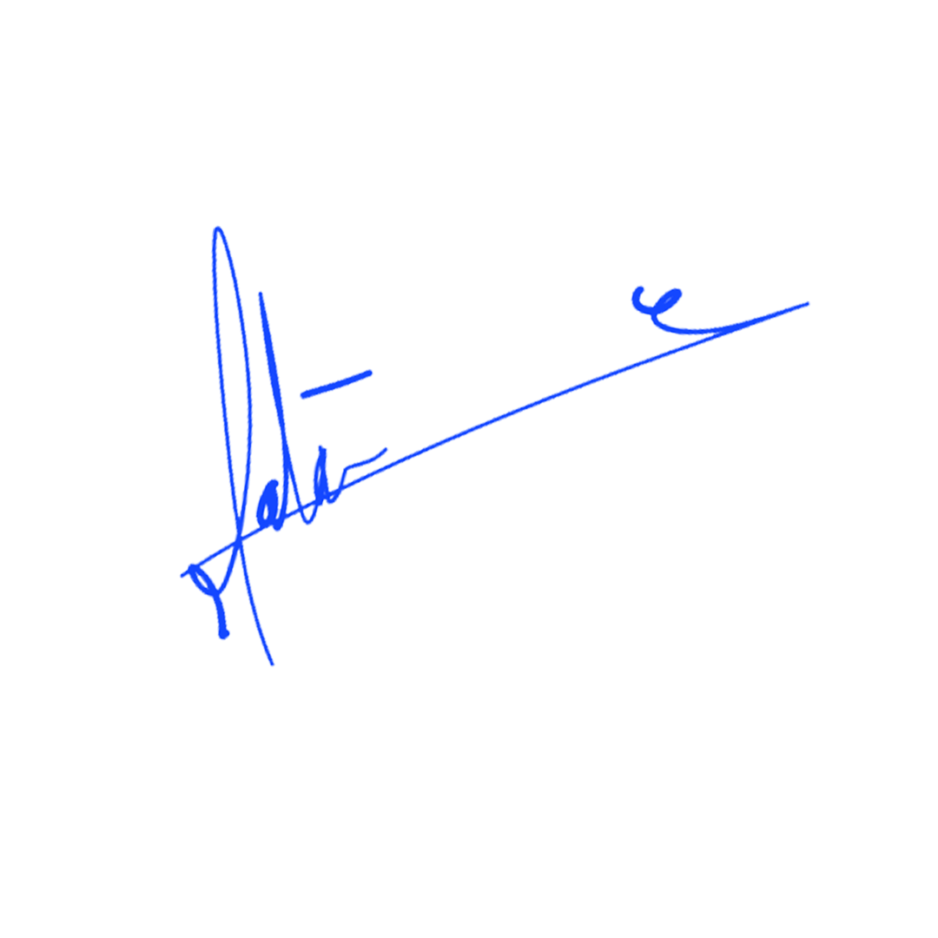
Program Director

Saad Matar

Strategic Research Director
Khaled W.Sabbagh

